Question 1: Find out the mail servers of the following domain : Ibm.com Wipro.com

In command prompt used nslookup command

And and set type=mx to find out Mail Servers.

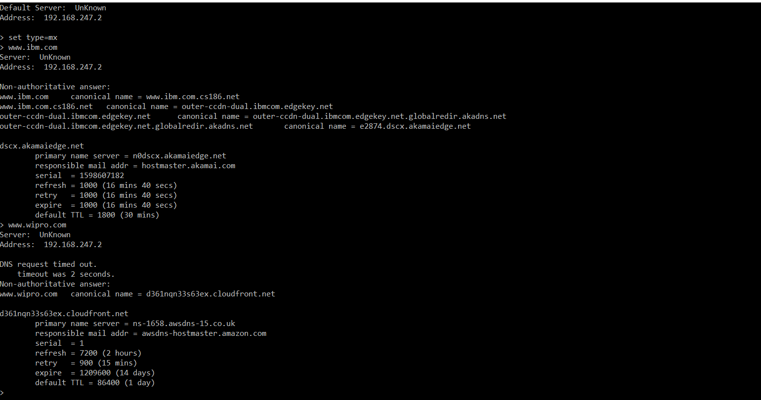

Question 2: Find the locations, where these email servers are hosted.

Used this Website to find out the Location of Mail Servers

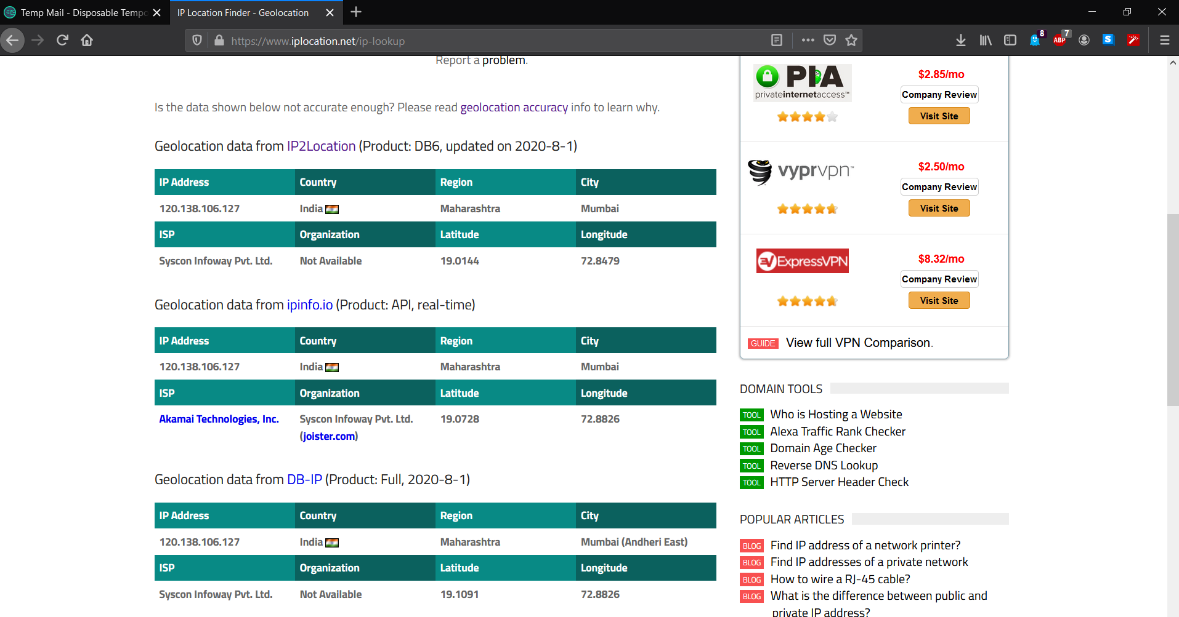

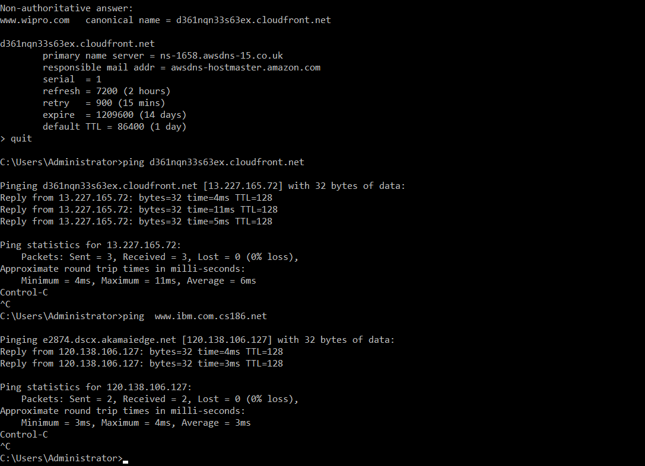 Used Ping command to get IP address for Mail Server Hostnames.

Wipro Mail Server Location

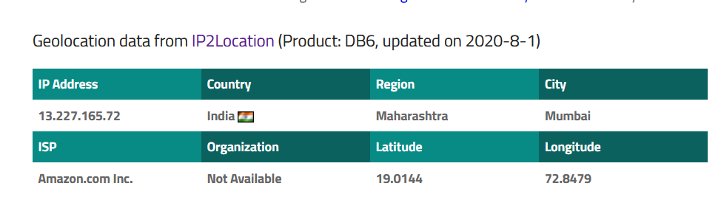

IBM Mail Server Location

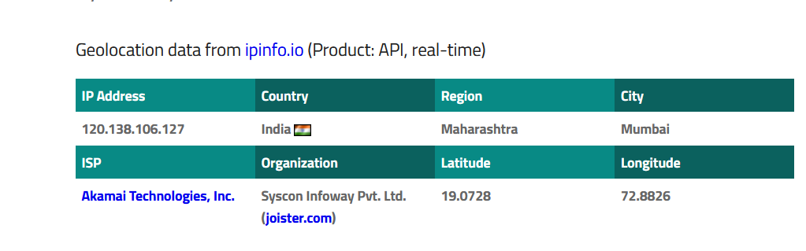

Question 3: Scan and find out port numbers open 203.163.246.23

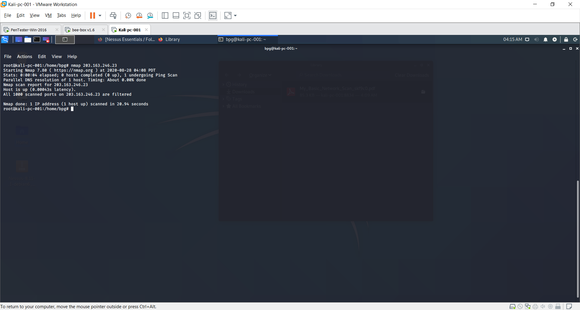

Question 4: Install nessus in a VM and scan your laptop/desktop for CVE

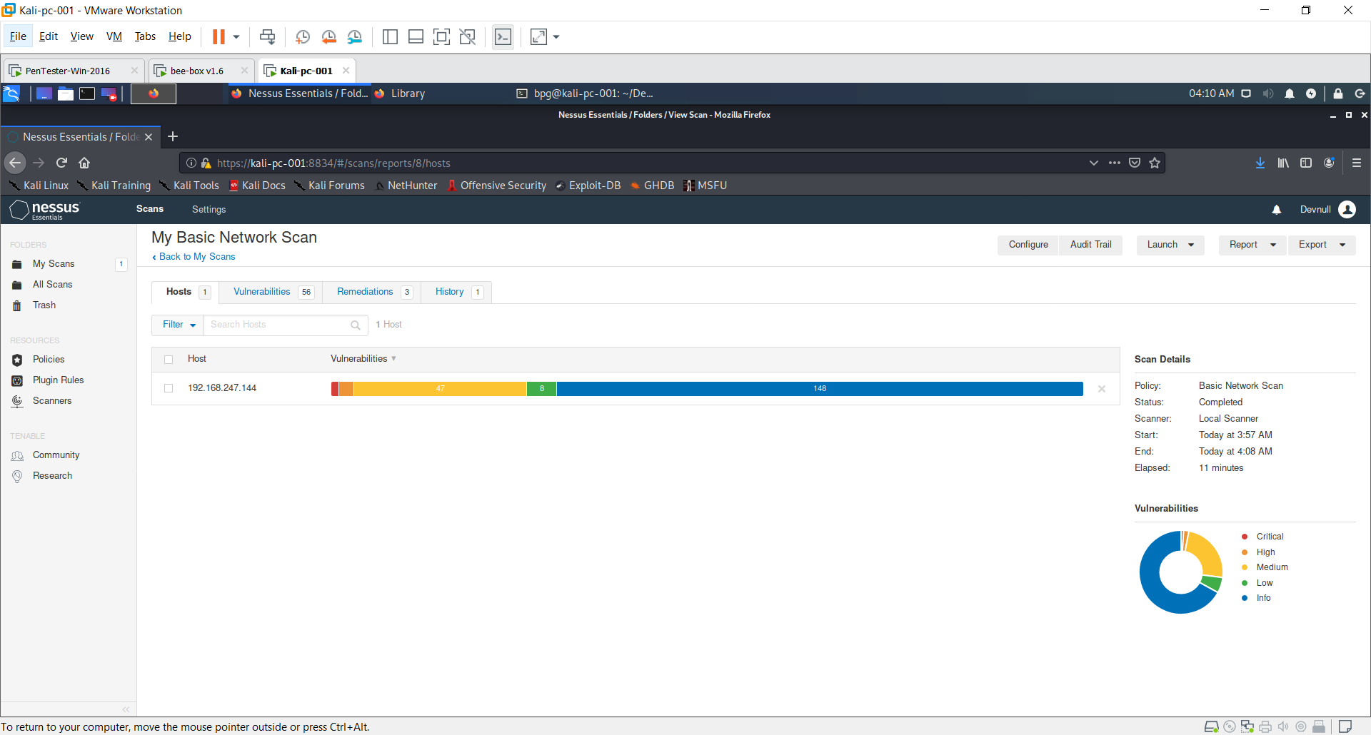

Scanned Beebox VM and generated report .